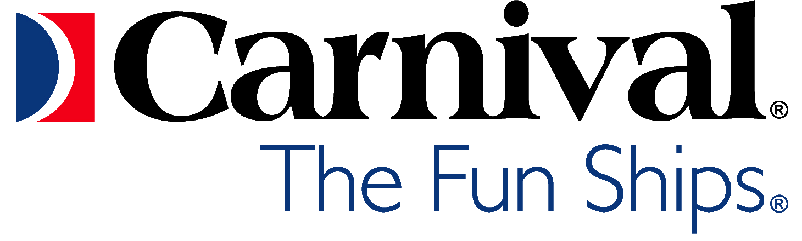
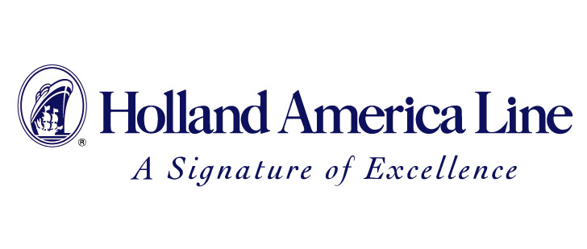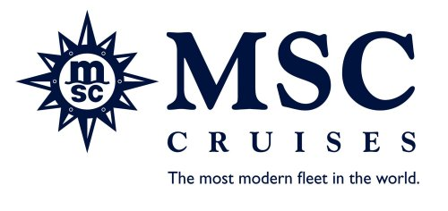
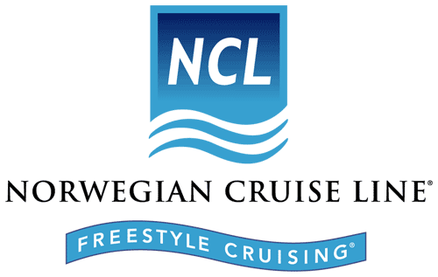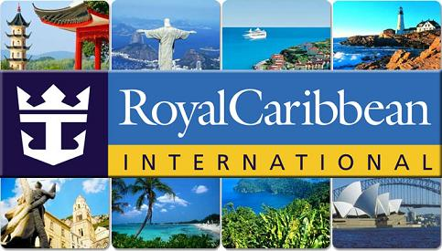

ASA MEMBERS – CRUISE LINE APPRECIATION

THE ABOVE CRUISE LINES WOULD LIKE TO EXPRESS THEIR THANKS FOR YOUR PAST SERVICE. TO SHOW THEIR APPRECIATION, THEY ARE EXTENDING EXCLUSIVE RATES TO OUR ASA MEMBERS AND THEIR FAMILIES ON SELECT SAILINGS, PLUS PROVIDING A DONATION TO VERN GREUNKE’S (HEYVERN@ASALIVES.COM) ASA CHARITY.

WHEN YOU CRUISE WITH US, YOU CAN ENJOY EVERYTHING, INCLUDING AN OCEAN VIEW SPA, NUMEROUS BARS AND LOUNGES, AWARD WINNING ENTERTAINMENT AND MOUTHWATERING DINING OPTIONS. PLUS WITH THE FREEDOM OF ENJOYING THE FELLOWSHIP OF SOME OF YOUR ASA BROTHERS.

SO PACK UP YOUR GEAR AND GET READY FOR SOME REAL REST AND RELAXATION, BECAUSE IT’S YOUR TIME TO SAIL AWAY WITH SOME OF YOUR ASA BUDDIES TO SHARE LOTS OF LAUGHS AND GREAT MEMORIES (DON’T FORGET TO PACK YOUR GEAR WITH SOME OF YOUR FAVORITE AGENCY STORIES FOR ALL OF US TO SHARE).

FOR MORE INFORMATION & AVAILABILITY OF CRUISES IN YOUR AREA, CONTACT:

ROBERT BIRK, ASA/HQCO 8621 DU (1954 to 1956)
2402 WAVERLY AVENUE
MEDFORD, NEW YORK 11763
PHONE: 631-447-1892
E-MAIL: BOBATDMP@YAHOO.COM

